**Energy4Climate**

The Drahi-X building demonstrator

Apr 2022

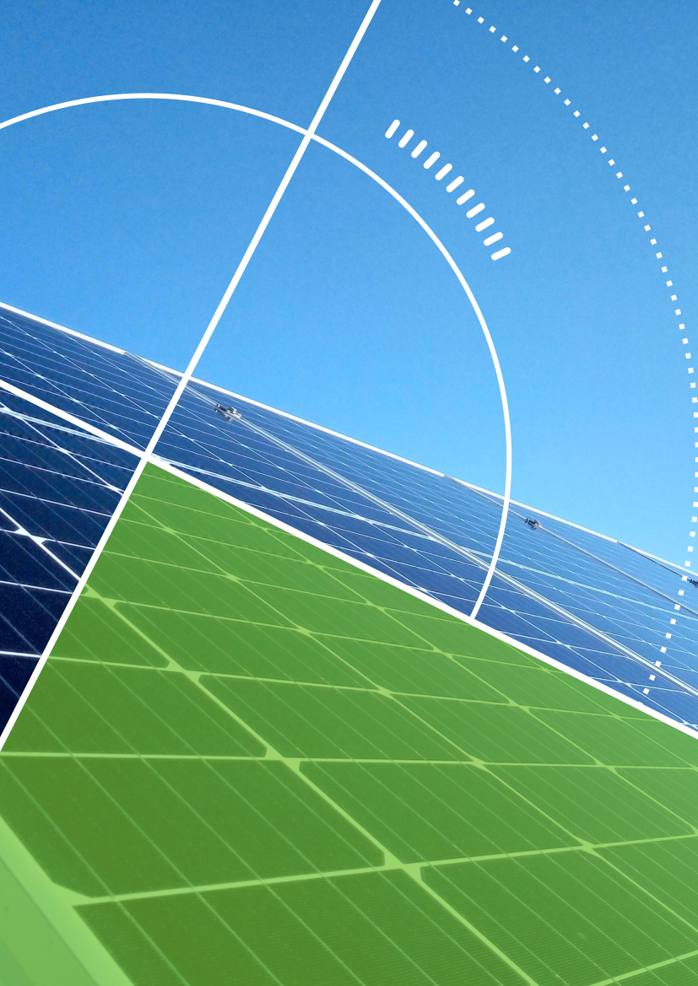

Table des matières

1. Context and objectives 3

2. Demonstration elements 4

2.1. Photovoltaic installation 5

2.2. Electrochemical storage capacity 7

2.3. Egauge electricity meters 9

2.4. Spoony smart-meters from Dotvision 11

2.5. Vehicle2Home charging station and electric car 14

2.6. Smart Building management System 16

# Context and objectives

According to the International Energy Agency[1], the buildings and construction sector accounted for 36% of final energy consumption and 39% of energy and process-related carbon dioxide (CO2) emissions in 2018. At the same time, nearly 40% of CO2 emissions come from buildings[2] and space heating remains the most important end-use, especially in the residential sector (68% in Europe)[3].

The current energy transition is shifting consumption towards electric, notably with heat pumps and electric vehicles. Both are directly linked to buildings, which are also becoming energy producers, particularly from renewable resources such as photovoltaics, which implies the development of sober, efficient and flexible energy management solutions.

The service improvement thanks to Smart Buildings should be evaluated by benefit/cost analyses through performance indicators. These indicators would be of different nature: economical (for instance through the electrical bill change), environmental (the carbon foot print of the used electricity), related to services to the grid (such as load shedding during peak periods) or well-being related (such as user satisfaction, comfort or new user services).

In this context, the demonstrator in the Drahi-X Novation Center at Ecole polytechnique was designed and up-stream studies were undertaken mainly to study the consumption profiles and the energy flexibility potential of the building.

The Drahi-X building is a tertiary building with around 5000 m2 of surface, and the main activity is start-up accelerator and incubator. Most of the space is filled with offices and meeting rooms, although there are also some labs, and in particular a Fablab.

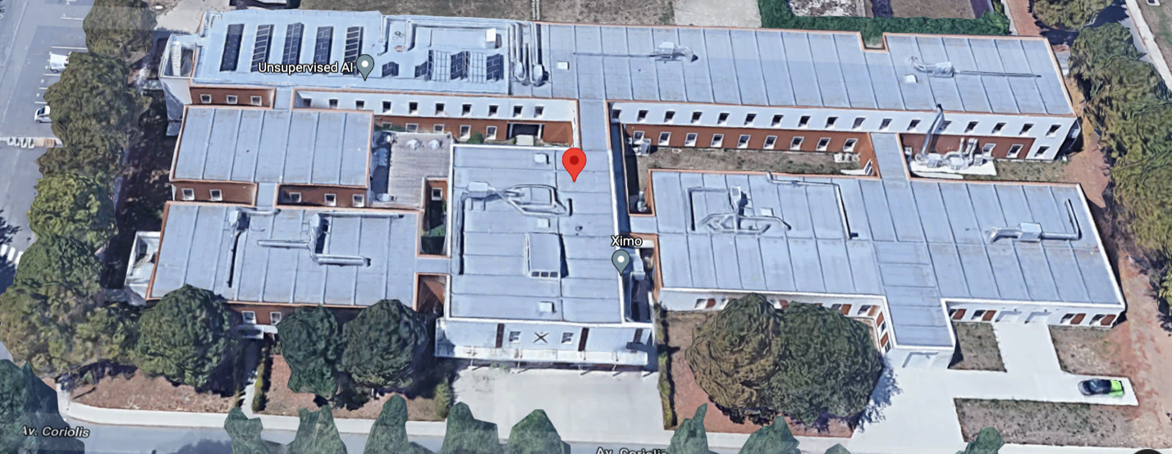

Figure 1 View of the Drahi-X Novation Center building (source: Google Maps)

The objectives of the demonstrator in the frame of the GPS project are:

* Metering and sub-metering of the building and the electric vehicle (monitoring, consumption, production)
* Smart Charging of electric vehicle: regulation of the charge and discharge of the car by controlling the terminal. Calculating the carbon footprint of the electric vehicle user
* Coupling of services related to self-consumption of the microgrid: smoothing of demand according to weather and PV production, frequency regulation...

The demonstrator construction was led by the Energy4Climate (E4C) interdisciplinary Center of IP Paris and Ecole des Ponts and counted with co-funding from the Chaire DTER (Défis technologiques pour une énergie responsable). AVNOR was in charge of the installation of the majority of the elements (in particular the PV installation, the battery, the electric vehicle charging point and all the associated components). Belenn Ingéniérie was the project builder (Maître d’oeuvre)

The demonstrator counted with the collaboration of 6 GPS partners:

* LMD/Ecole polytechnique/E4C, for the coordination of the installation of all élements and the definition of the photovoltaic plant + battery storage capacity,
* Dotvision, for about 15 Spoony smart meters and the creation of the data flow,
* Elum Energy, for the management and control system of the battery and photovoltaic inverters
* Clem' for the control of the Vehicle2Home bi-directional terminal and the provision of the car-sharing system.
* Luceor, which brings the wimesh communication infrastructure to provide mobile broadband internet services.
* And Evolution Energie, responsible for the business model with blockchain and dahsboards.

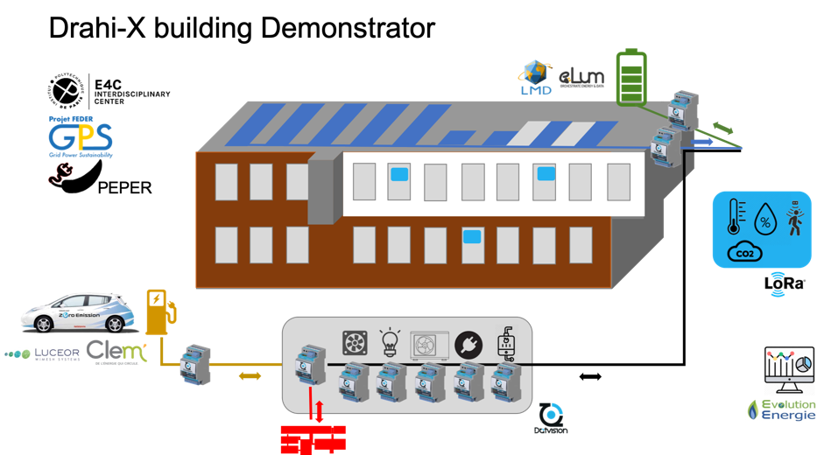

Figure 2 Scheme showing the components of the demonstrator for the Drahi-X Novation Center building. The different start-ups involved in the demonstrator are indicated in the corresponding components of the system.

# Demonstration elements

In the following sections we describe each of the key elements of the demonstrator and the tests that have been done with them

## Photovoltaic installation

A rooftop PV platform have be installed filling the available space for the demonstrator, that is around 300 m2. The PV capacity is 16.7 kWp with 53 PV modules.

In addition to its role to supply electricity for the demonstrator, this PV platform was designed to host research and training activities on PV performance. The scheme in Figure 3 shows the concept with the following characteristics:

* 6 PV module types are considered, including mono-Si (black and white backsheets), PERC, half-cell PERC, bifacial PERC and Qcells.
* 2 tilt configurations: 20º and 30º
* Two reflector planes in front of two rows of PV modules
* DC/DC optimizers for each of the 53 PV modules of the installation



Figure 3 3D scheme of the roof-top PV installation for the Drahi-X Novation Center. Each color correspond to a different PV module that are shown in detail in the right bottom corner of the figure.

These configurations allow multiple cross-comparisons for PV performance analyses in addition to PV modelling at the module and system levels.

The installation was commissioned on 17 July 2020 and, during the first year of operation, it produced 20.4 MWh for 16.7kWp, which is 1221 kWh/kWp. That is on the high range expected for the Paris region (rather sunny year). The months with more and less production were April (2.57 MWh) and December (0.38 MWh), respectively, and the day with more production was May 30th 2021 (125 kWh).

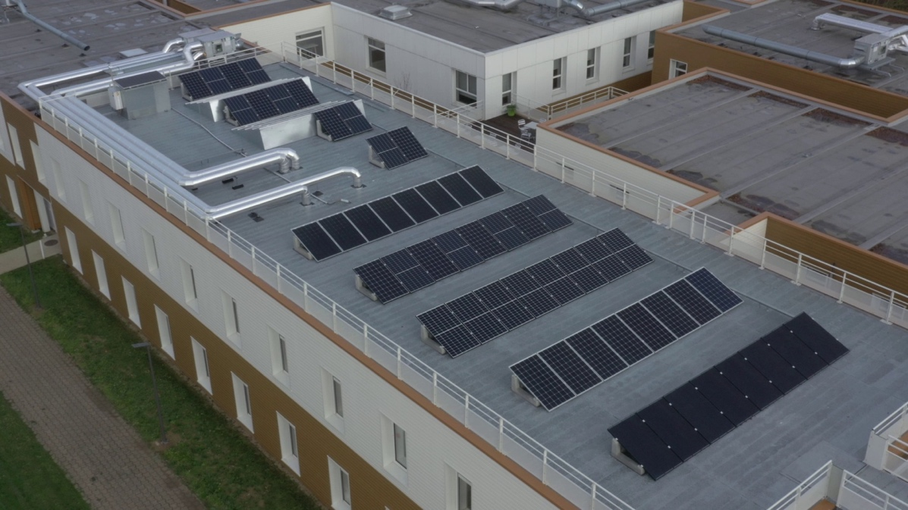

Figure 4 View of the Drahi-X photovoltaic roof-top installation

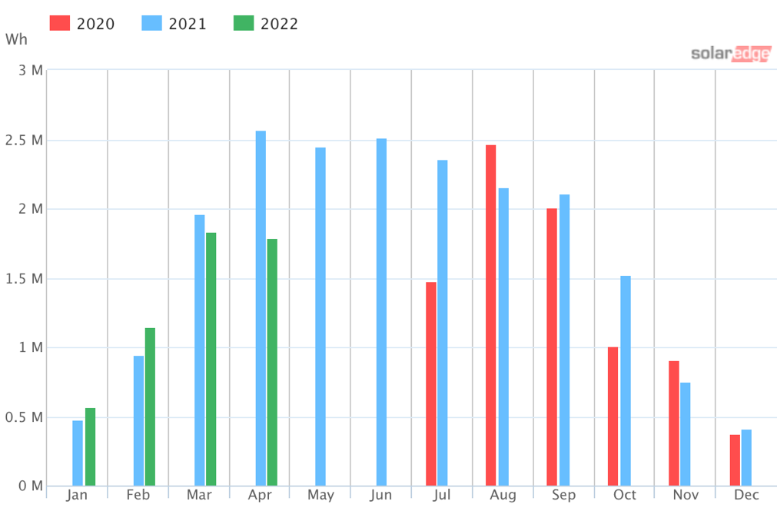

Figure 5 Monthly energy production of the Drahi-X photovoltaic installation.

|  |  |
| --- | --- |
|  |  |

Figure 6 Daily energy PV generation for December 2020 (left) and April 2021 (right).

## Electrochemical storage capacity

Two BYD batteries of 30kWh of storage capacity were installed on the roof next to the PV installation. Three Victron Multiplus 5000 inverters were installed, one per phase. The installation was done in a way that the PV and battery parts were only connected on the AC part, that is that separate battery and PV inverters were installed as shown in Figure 7. Figure 8 shows a view of the installation on the roof of the Drahi-X building.



Figure 7 Wiring scheme for the PV - battery - EV charging - Load parts of the system

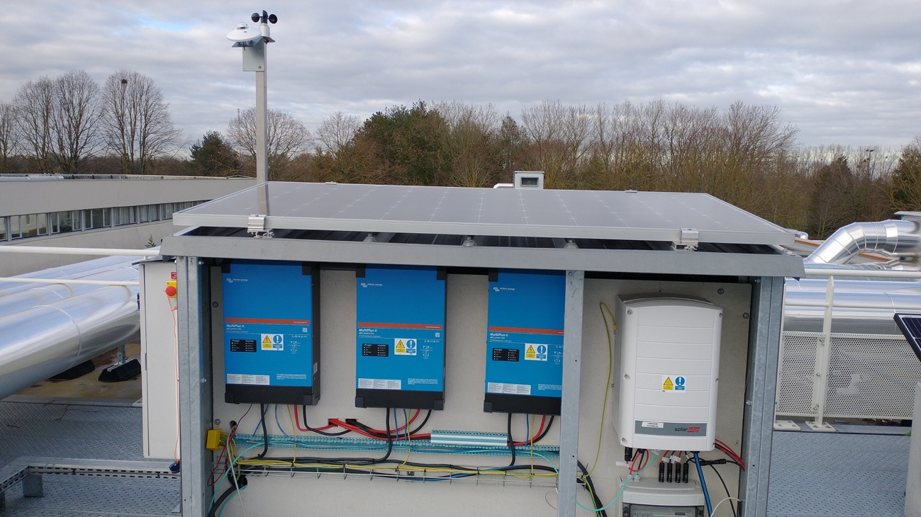

Figure 8 View of the battery (in blue) and PV (in blanc) inverters on the roof of the Drahi-X building

Commissioning tests were done by Elum on April 2021 on the photovoltaic and batteries inverters (Figure 9).

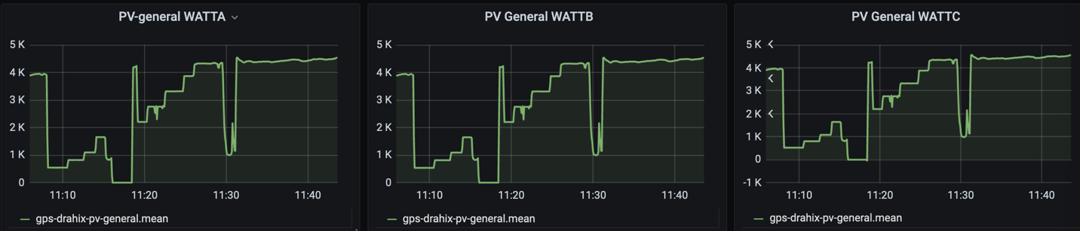

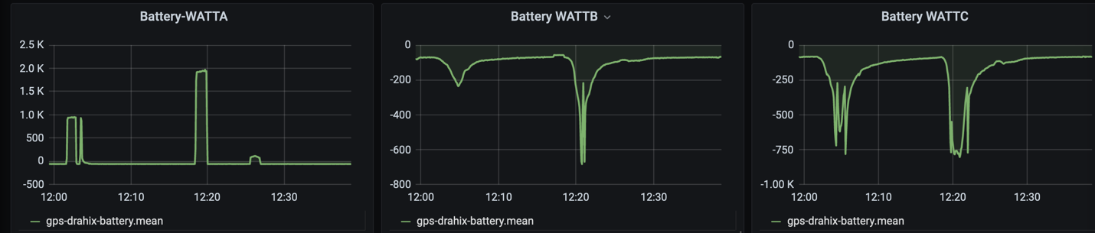

Figure 9 Commissioning tests on the photovoltaic (top, shown in the step-like shapes) and battery (bottom) inverters on 12 Avril 2021. For this latter, only phase A could be controlled, and the control of the other two phases is under investigation.

By then end of 2021, a calendar-based EMS was deployed by Elum. For this, a certain number of control parameters were set and their values were fixed for different time slots. Two main strategies for the control of the batteries are considered: “self-consumption” and “Fixed charging”. See some of the details in Figure 10.

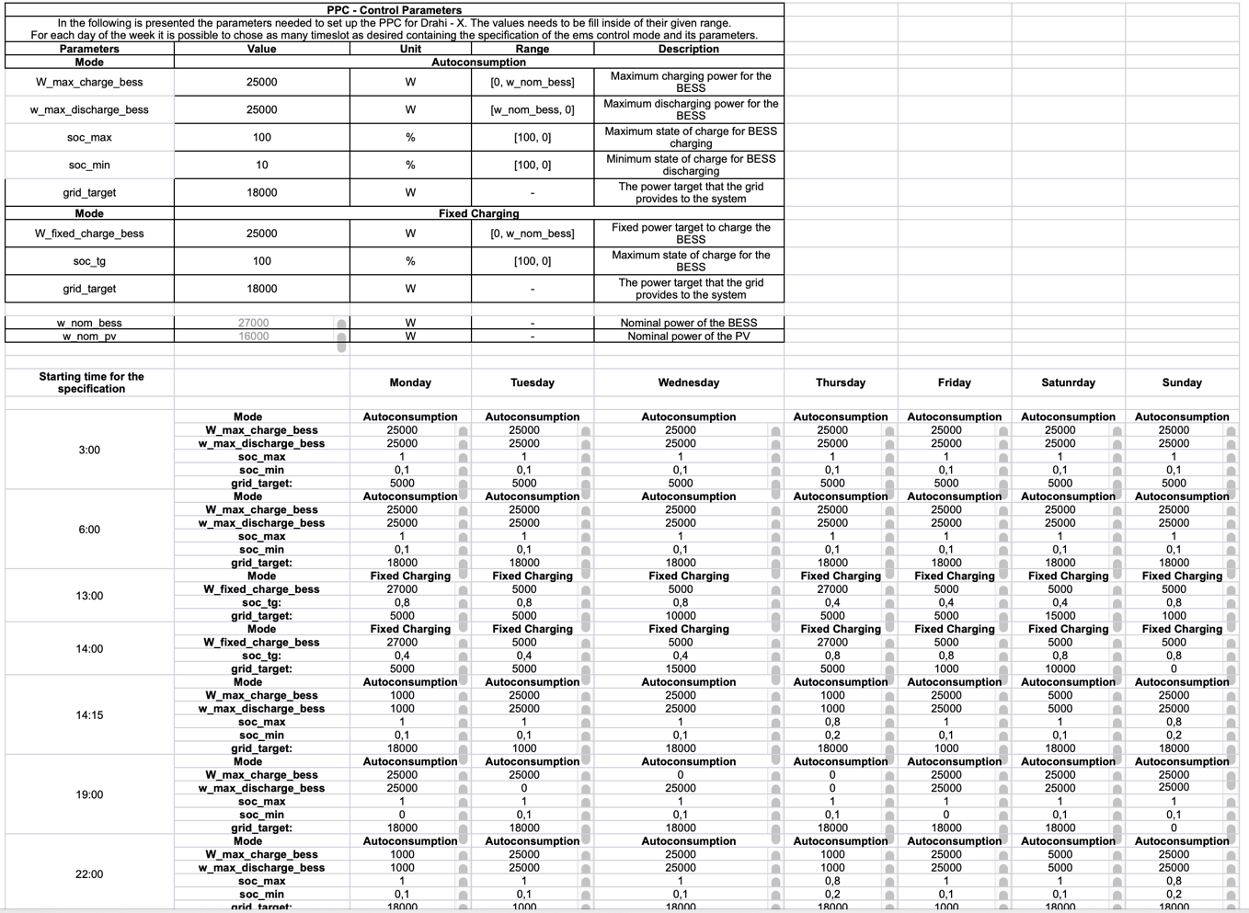

Figure 10 Power control parameters (top table) and time slots by day (bottom table)

This calendar-based EMS (see Figure 10) will become dynamic in 2022, allowing changing the batteries power during the day depending on given measured or forecasted information.

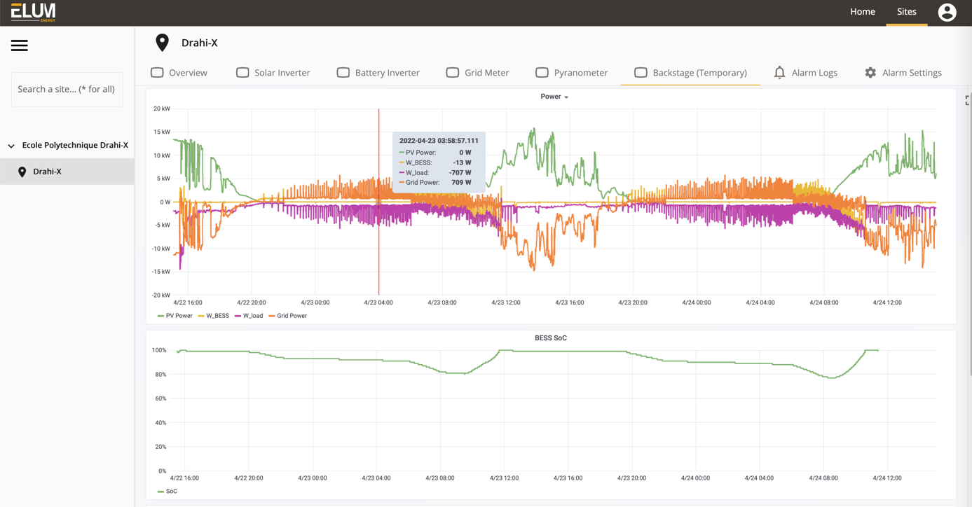

Figure 11 Screenshot of the Elum Energy interface showing two days of PV production (green), battery (yellow), grid (orange) and load powers

## Egauge electricity meters

Electric consumption of the Drahi-X building is measured since July 2016. First measurements were for the total consumption of the 7 electric zones that existed by then as well as the global electric consumption (Figure 13 and Figure 14) using egauge meters (www.egauge.net). Measurements are stored at 1 second resolution since then.

|  |  |
| --- | --- |
|  | Shop eGauge Meter with 6 3/4" CT Kit  1{f5420117598d0d58a0320a09949d80ddd229fae4aaa29fc145975afd162f3ada} Accuracy |

Figure 12 (left) Location of the 7 electric Zones of the Drahi-X buildings for which consumption measurements exist since July 2016 (right) photo of the type of egauge devices installed (www.egauge.net)

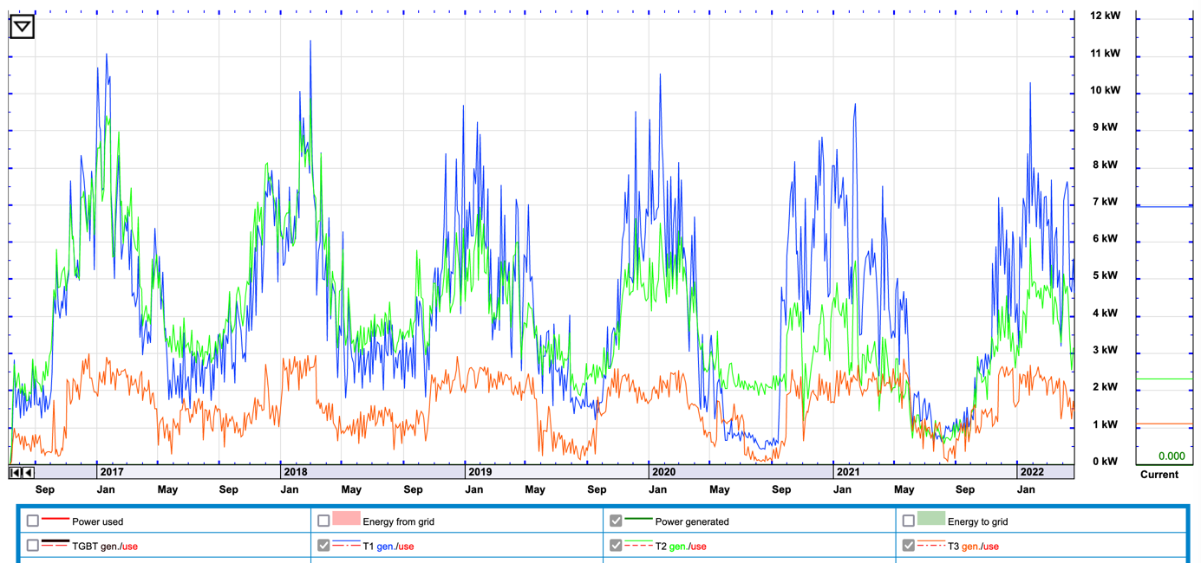

Figure 13 Screenshot of the electric consumption for Zones 1-3 of the Drahi-X building using egauge meters (since July 2016).

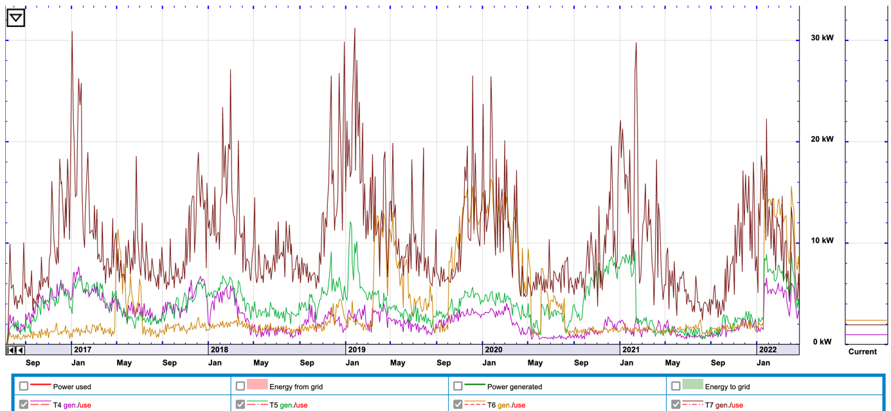

Figure 14 Screenshot of the electric consumption of Zones 4-7 of the Drahi-X building using egauge meters (since July 2016).

In April 2018, two new egauge devices were installed in Zones 1 and 2 in order to measure the consumption by type (heating/cooling, ventilation, plugs, lights and water heater). Data is also stored at 1s resolution since then. Figure 14 and Figure 15 show the evolution of these measurements since then. They show that main consumption is due to Heating during the cold months.

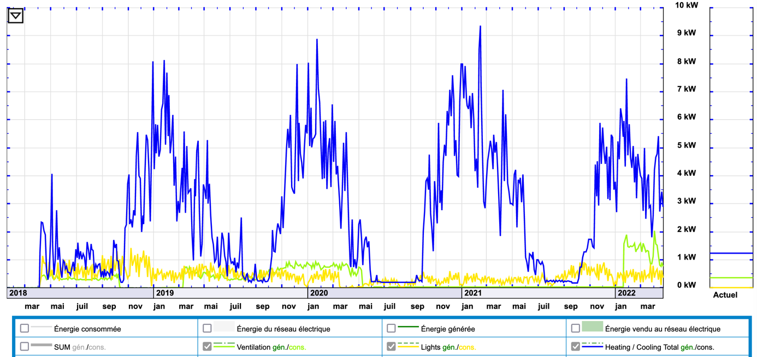

Figure 15 Screenshot of the electric consumption of different types in Zone 1 since April 2018

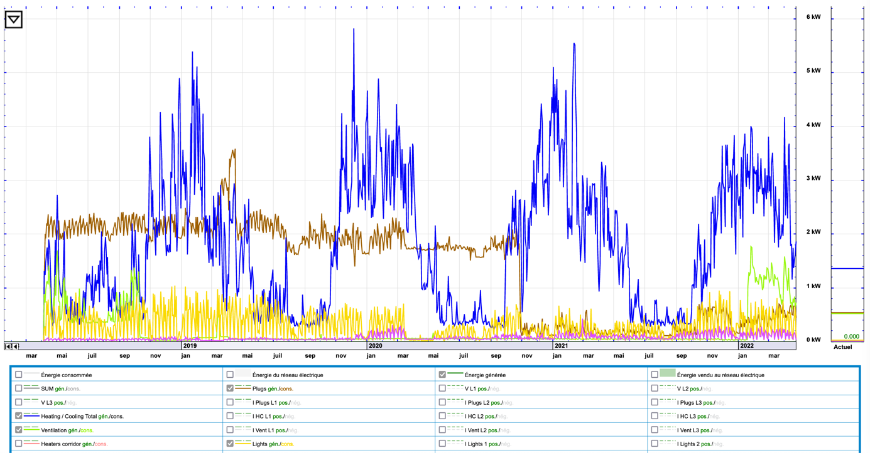

Figure 16 Screenshot of the electric consumption of different types in Zone 2 since April 2018

## Spoony smart-meters from Dotvision

By the end of 2018 the new construction works started in the building in order to double the surface size. One of the consequences was the appearance of 4 new electric zones and a new general low voltage electric panel (TGBT). The measurement of the electric consumption for these new zones was done within the framework of the FEDER GPS project.

DotVision was in charge of installing smart energy meters (Spoony) to monitor the electricity consumption or production of these new zones in the Drahi-X building. The devices that were installed are:

5 Spoony in the TGBT cabinet for monitoring the general consumption of the building as well as the heavy machinery, Fujitsu, office and management circuits (Figure 8). Installation done on 6 Dec 2019.



Figure 17 View of the 5 Spoony devices in the TGBT cabinet of the Drahi-X building.

7 Spoony in the 604 electrical cabinet (Figure 12) for consumption monitoring of the general electrical supply and lighting, heating, cooling, and outlet circuits and the EV terminal consumption. The installation were done on 7 Dec 2019.

Figure 18 View of the 604 electric panel after having installed 7 Spoony devices in two zones that are zoomed-in on the right. The orange zone contains a Spoony that allows to open/close the water heater circuit remotely.

2 Spoony where installed on 3 Sep 2020 on the roof of the building to monitor the photovoltaic panels and the batteries.

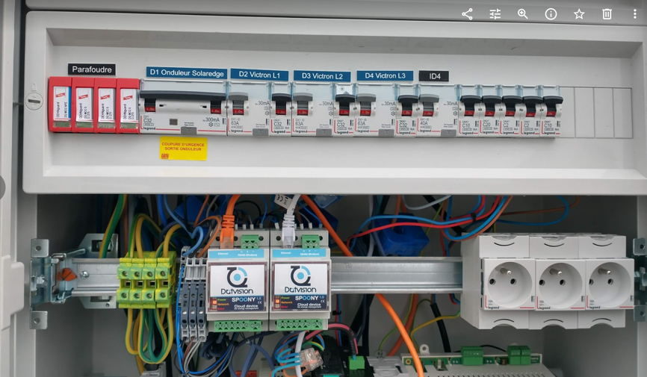

Figure 19 View of the electric panel on the roof of the Drahi-X building after having installed two spoony devices in order to count the photovoltaic and battery electricity.

1 Spoony was added in the 604 cabinet on Jan 13 2021 to measure the electricity exchange with Vehicle2Home charging point.

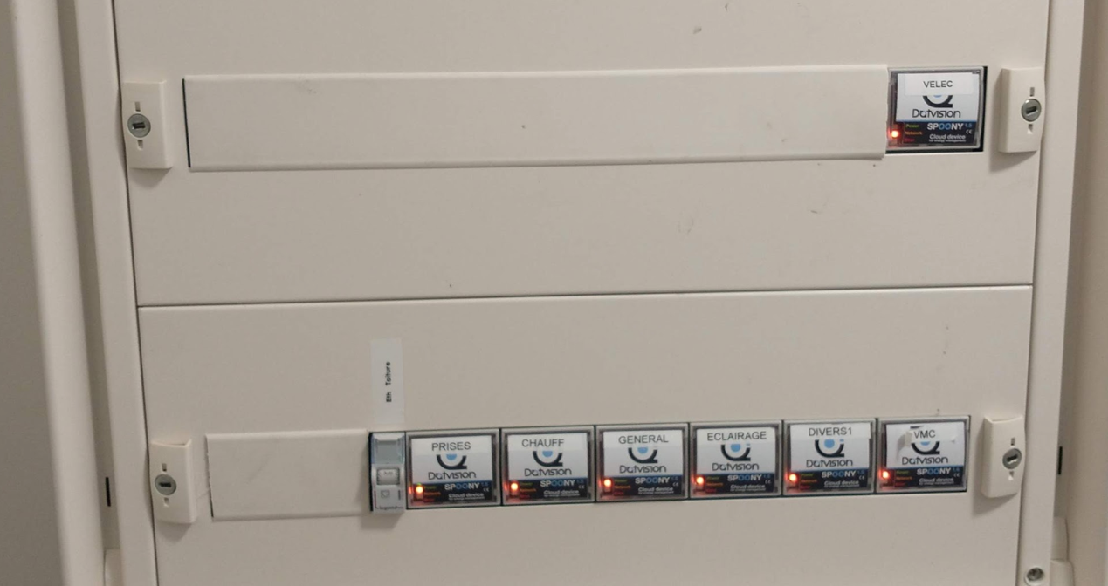

Figure 20 View of the 604 electric panel after having added the Spoony to count the exchanges with the Vehicle2Home charging statoin

Dotvision set a MQTT flux to which each partners can be clients. The data is stored and presented in real time based on a Influx-Grafana configuration (Figure 15)

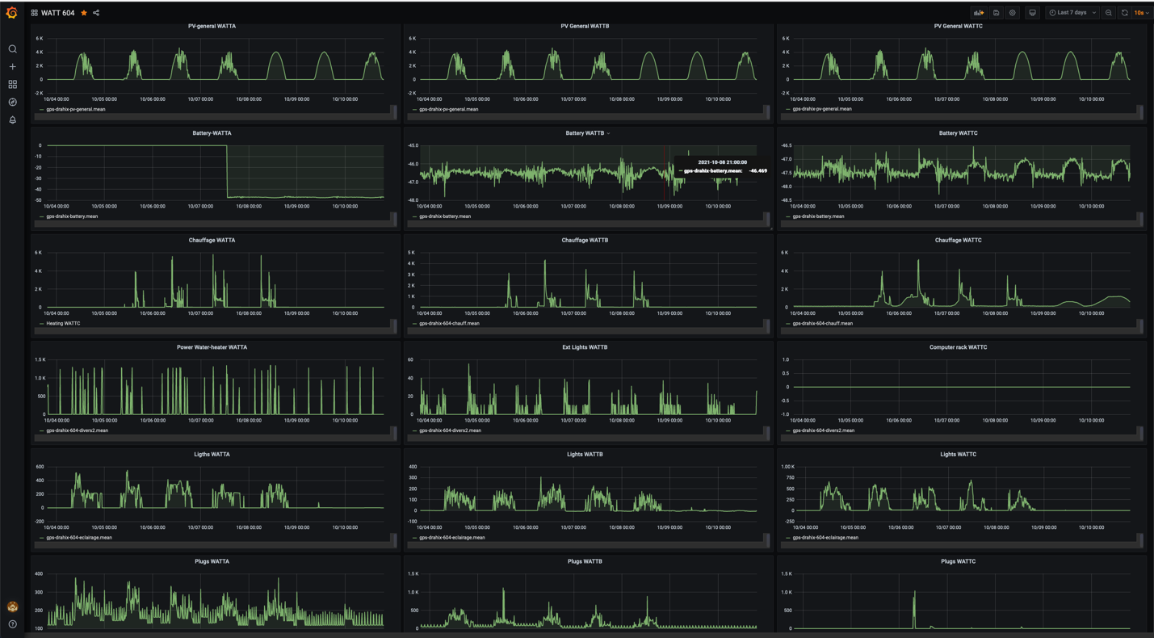

Figure 21 View (Grafana interface) of the Spoony data for 7 days for different types of consumption (different lines) and for each phase (columns).

­­

The data, at high temporal resolution, allow visualizations and studies like the ones shown in Figure 16

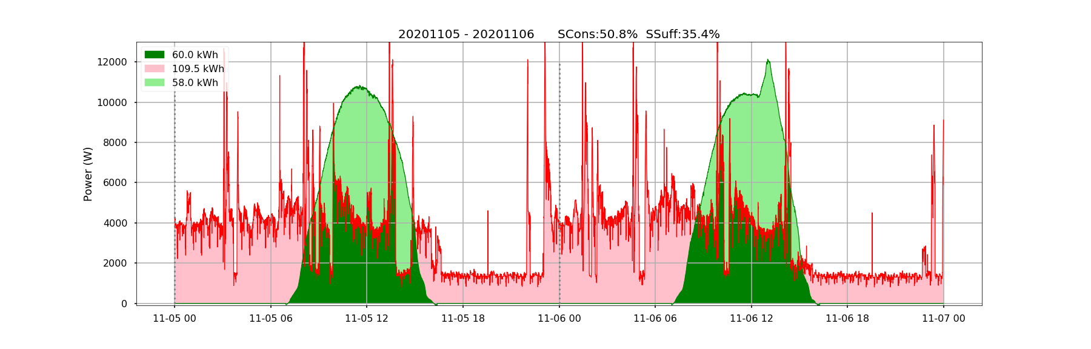

Figure 22 Spoony power visualisations for PV and consumption in zone 604 of the Drahi-X building for a 2-day period

## Vehicle2Home charging station and electric car

An ENEL X Vehicle2Home charging point was installed next to the Drahi-X building and physically (electrically) connected to it.



Figure 23 The Clem's vehicle that is available for the demonstrator being connected to the ENEL X charging station.

A test on charging and discharging an electric vehicle was done, showing the capability of the charging station to allow electricity exchanges in both ways.

A Nissan NV200 is made available by Clem for the demonstrator, which can be booked through Clem’s online platform (web and APP).

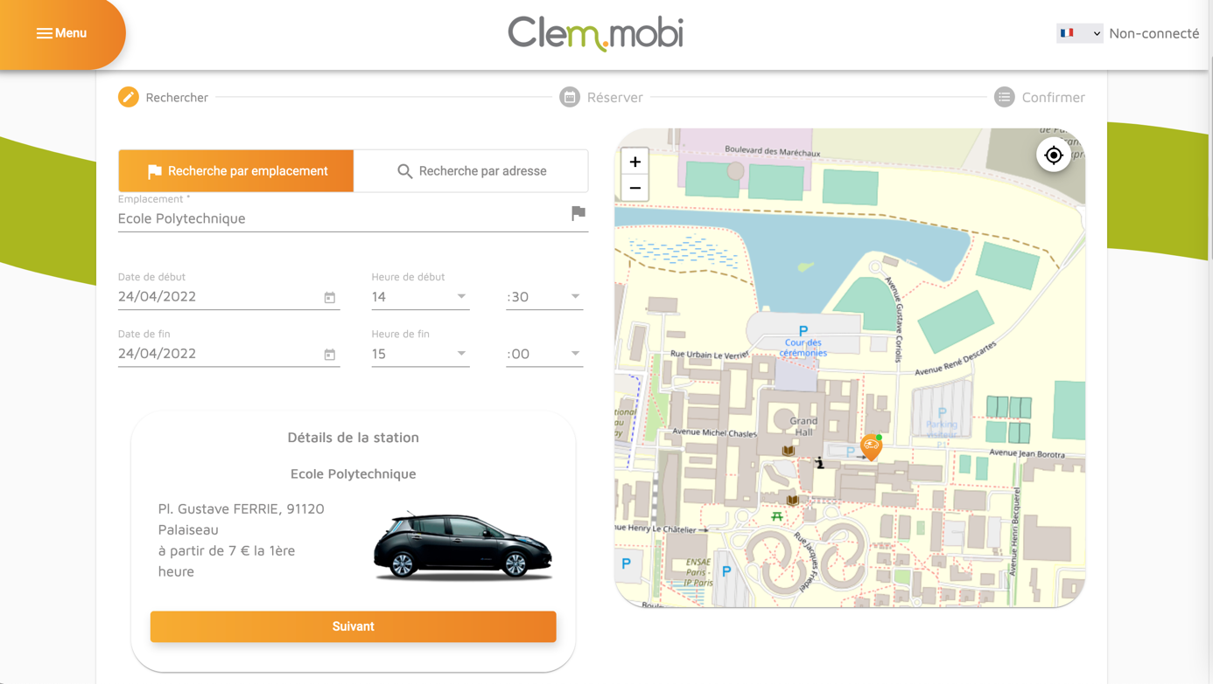

Figure 24 Clem's reservation platform showing the presence of the car available for car sharing at the Drahi-X building level

|  |  |
| --- | --- |
|  |  |

Figure 25 Power tests on the ENELX V2H charging station. Positive power (in the regions marked with “C”) indicates the moments for which the station was used to charge the electric vehicle. Negative power (in the region indicated with “D”) indicates the moment for which the electric vehicle was discharged to supply electricity to the building.

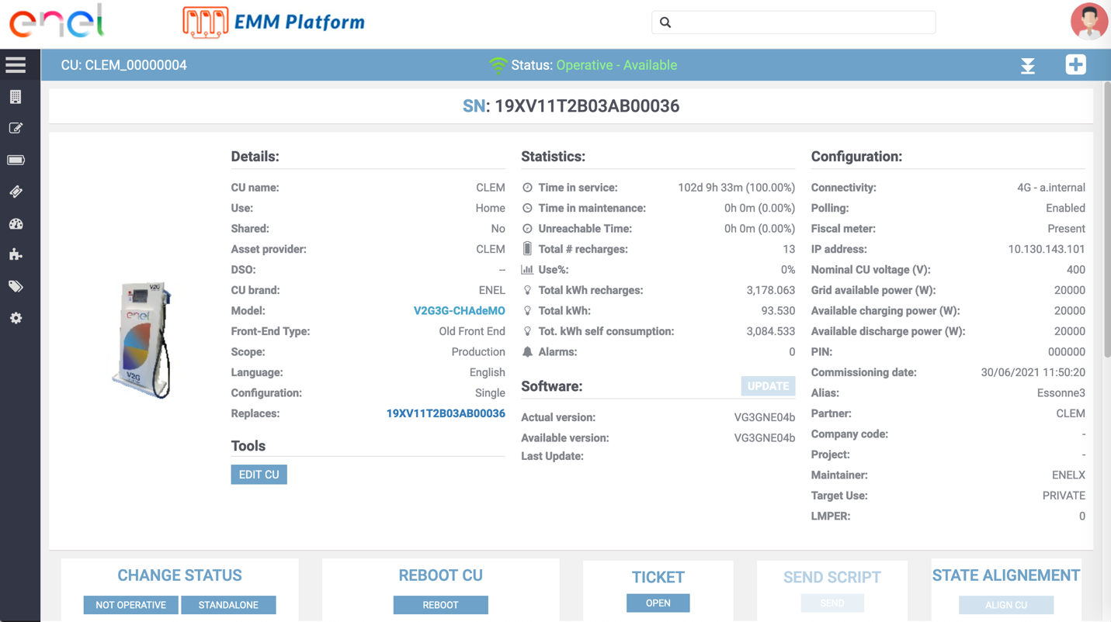

Figure 26 ENEL's platform that contains the information on the V2H station and allows some actions remotely.

## Smart Building management System

From the beginning of 2022 a new building management system (BMS) will be commissioned at the Drahi-X Building, which will allows controlling and having access to all the measurements from the heat pump and ventilation systems. The BMS will be proposed by ACCENTA, and the heating-cooling-ventilation systems will be automatically controlled using predictive control based on artificial intelligence. The system will allow remote control from research algorithms.

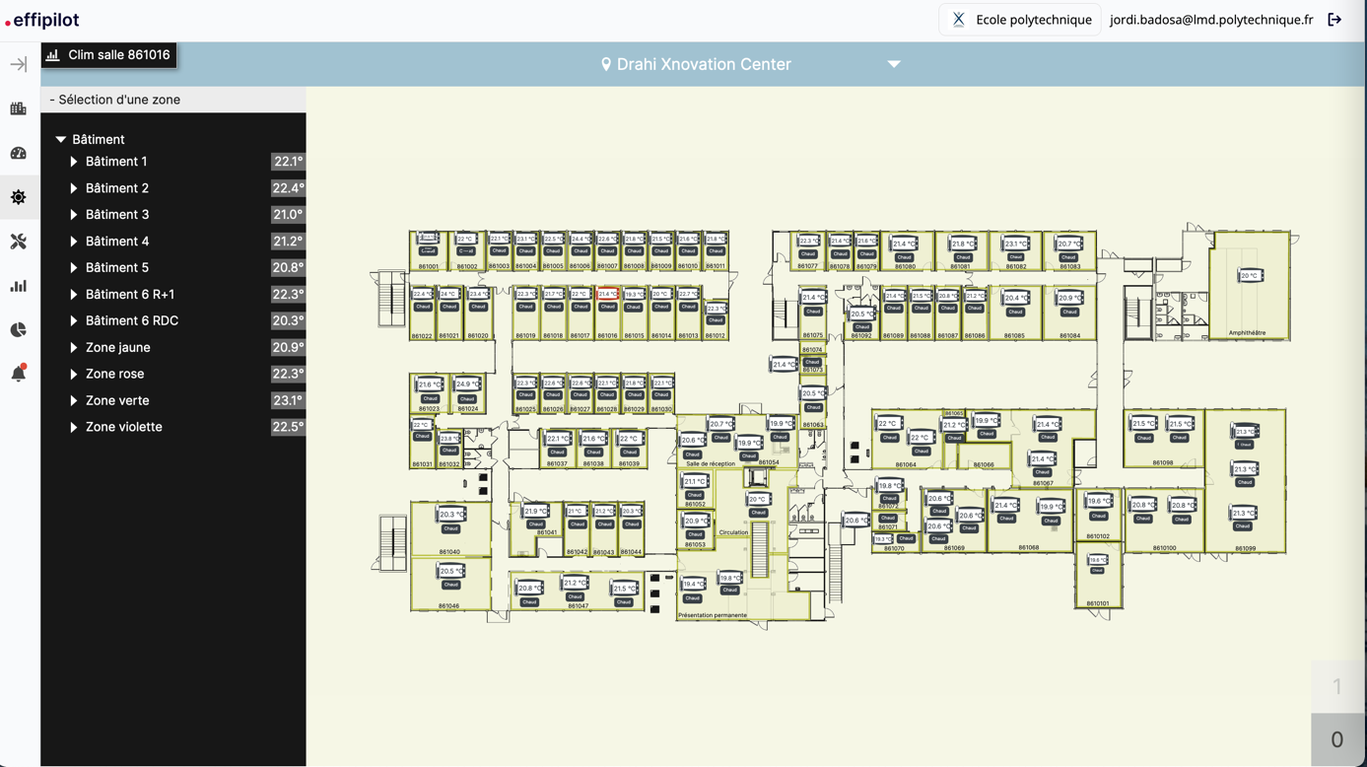

Figure 27 Screenshot of the Smart building management system platform (Effipilot, from Accenta)

1. https://www.iea.org/reports/global-status-report-for-buildings-and-construction-2019
2. https://seeedcollege.org/are-architects-responsible-for-some-33-40-co2-emissions/
3. https://ec.europa.eu/energy/content/energy-consumption-end-use_en